SRPG《Reverse Collapse:Code Name Bakery》responsible for the working example

Display system and UI two main business direction, each sample by 【technical solution】+【program execution】 two parts, the actual content can enter the Steam store view:

<https://store.steampowered.com/app/1127700/Reverse_Collapse_Code_Name_Bakery/>

1. System

* Module: Item System _ Team Items

Function description: Add special items that are enhanced by the shared attributes of all characters. They cannot be sold and are not displayed in the knapsack, but keep the same item storage and reading rules as other items, and can grow and enhance as the game progresses;

* Function and dismantling

1. Data layer

* Shared by all characters. Data stored in the new container, and all the role can access;
* Special props. Props for the new configuration table, 【ItemTeam】，UI related information can link to the original Item table;
* Not for sale. Can’t Sale for the item type is set the configuration of the field;
* As the game grew stronger. Props upgrades take the form of [Fragment Acquisition], obtaining fragments in the level will enhance the [existing] [type] team props; new team props development table [ItemTeamUpgrade], configure the props upgrading;

1. Logic layer

* Enhanced properties. Added [team item bonus] calculation function to the settlement formula of character attributes;
* In line with other props deposit to read the rules. Reading time are similar to ordinary props, but should be set separately in the archive variables, avoid confusion;
* To upgrade existing items. Set up the new function, when get new pieces, check for team props, new Lv1, has obtained the Lv + 1;

1. Presentation layer

* Levels in performance. Design new items special effects and checkpoints set up team props drops position, and play the new special effects;
* Get the item performance. New Windows UI design, props, by ItemTeamID link to the Item table, query UI information configuration and display;
* System to check the performance. Different from ordinary backpack position, and the other Settings TAB, and new interface UI display props team owns and bonus;
* Make plan
* Design direction
  + System Designer

ItemTeam, Item, ItemUpgrade, main configuration team props logical data (bonus), growth data (growth) per level, the UI display data (text)

* + Level Designer

Temporal and spatial information for obtaining team items in the level: obtaining time (achieved by level events), obtaining location (achieved by level generation of interactive objects)

* Program direction
  + Logic Part

Team item acquisition logic, team item upgrade logic, team item bonus logic

* + UI Part

Get popup window (including primary and updates), in the system view

* Art direction

Design the Effect table of the special effects configuration in the level, design the UI and related animations of the pop-up window, design the props icon of the team, and design the UI and related animations of the view page.

* Test and verification

Level two configuration modes (events, location), team props for the first time, updates the UI display correctly, save loading logic is reasonable;

* Spread out

After the verification, formulate the schedule, art, procedure and planning, and the three parties carry out in an orderly manner;

* Iterative optimization
* The paid bundle upgrades the team items X times. Increase team props to upgrade interface, in the gift bag is configured in the configuration table need to upgrade the team props fragment ID;
* Stage upgrade limit. In levels table LevelInfo, for all kinds of props team level cap restrictions, load determination, props team level has reached its limit, the levels of existing configuration failure (events, fixed location items);

1. UI

* Modules: Item Building _ Arsenal and accessories library

Function description: the assembly of different parts the weapon draw dynamic change

* Function disassembly.

Requirement disassembly specifies the point position matching problem for the image

* Develop a plan
* Collaboration interface

1. Extract the parameters required for image matching.

Including weapon size, accessory slot position array (pixels) on the weapon, accessory slot position (pixels), accessory slot type, accessory zoom (some accessories need to zoom to fit the weapon), occlusion level (front and rear occlusion when accessories overlap), new weapon ID (some weapons need to directly replace the new vertical drawing when assembling new accessories, such as knives)

2. Set the workflow

Through an online document form, collect summary data

* Art Direction

1. Uniform material sizes. The original material and part of the weapons do not have a unified specification, standard material specifications needed for accurate matching;

2. To determine the parameters of fine arts and tables. Determined by PS tools, such as the class information of pixels

3. The animation colleagues, setting dynamic effect, enter, hotspot hovering, etc;

* Design directions

1. Determine the planning parameters and make a table. Accessory slot type and replacement weapon ID;

2 Final effect acceptance.

* The program direction

1 Calculate the percentage offset based on pixels;

2. Match the accessories to the specified position of the weapon according to the type of accessories slot and the way of modifying the center anchor;

3. Adjust the UI sequence according to [occlusion level];

4. According to the new weapons ID directly replace state;

5. Cooperate with animation colleagues, to achieve dynamic effect;

* Demo validation

With boundary conditions (length, special weapons: knife), a small amount of material, lightweight code, quick test feasibility;

* Spread amount on

After the verification, formulate the schedule, art, procedure and planning, and the three parties carry out in an orderly manner;

* Iterative optimization

Function after molding, because the **low module coupling**, are relatively independent, weapons and accessories, animation can be independently modified, as long as the perfect own parameters;

No any accessories:

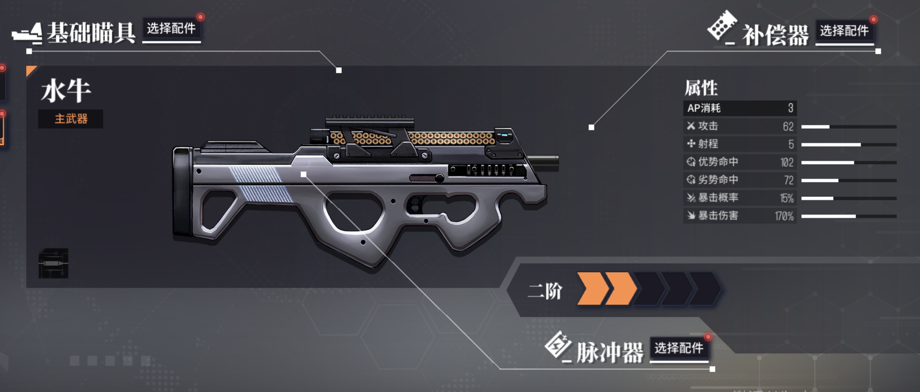

Assembly sight:

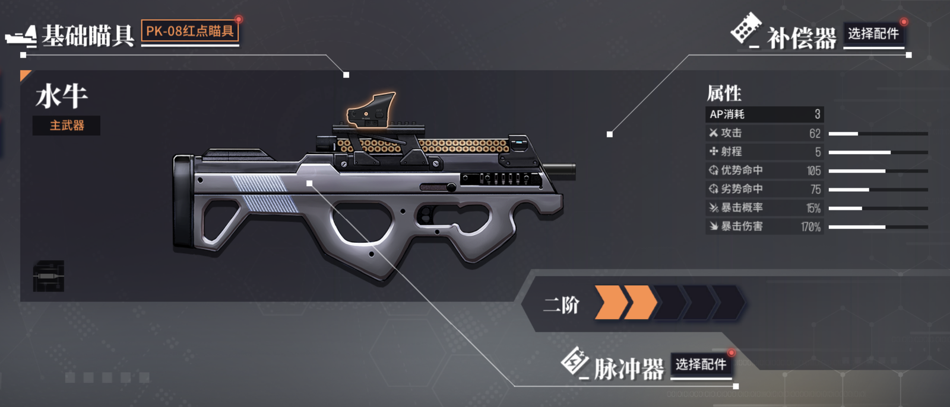

Reassemble compensator:

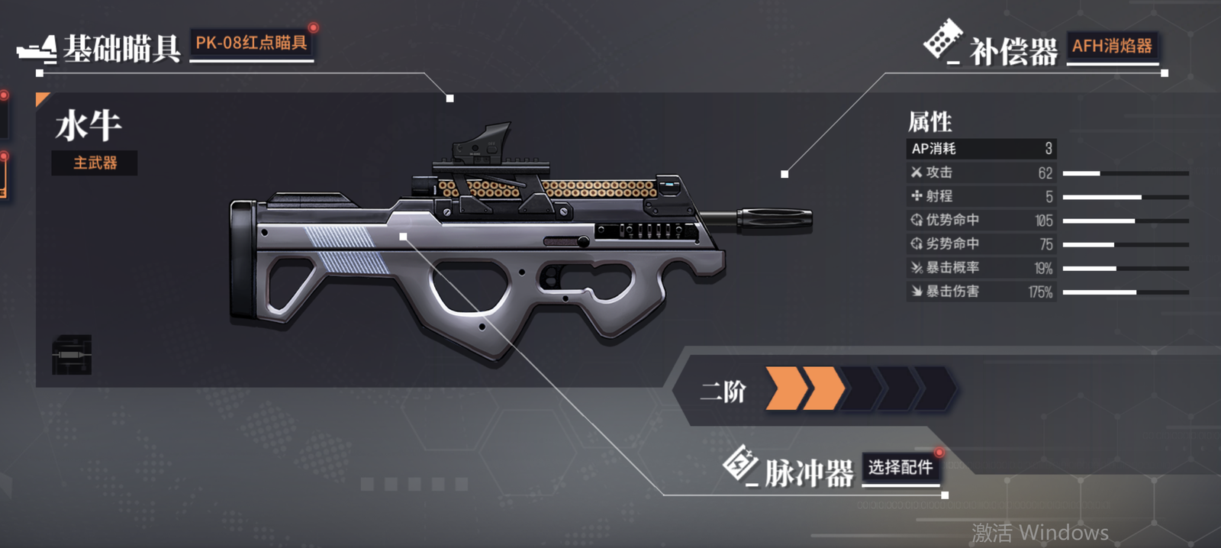

-- -- -- -- -- -- -- -- -- -- -- -- -- -- -- -- -- --

* Module: scene _ map edge effect

Function description: The player pointer has dynamic performance on the edge of the map

* Function and dismantling

Demand apart for map edge performance is not limited to land, the banner of the function relation with cursor position

* Make a plan
* Art direction

Provide the specified material

* Program direction

1. To provide program function formula. Pointer distance from edge and corner as parameters, call material, Alpha value, position value as output;

2. Determine the resource loading and unloading time;

* The Demo verification

With several different gate size, background brightness, as a test 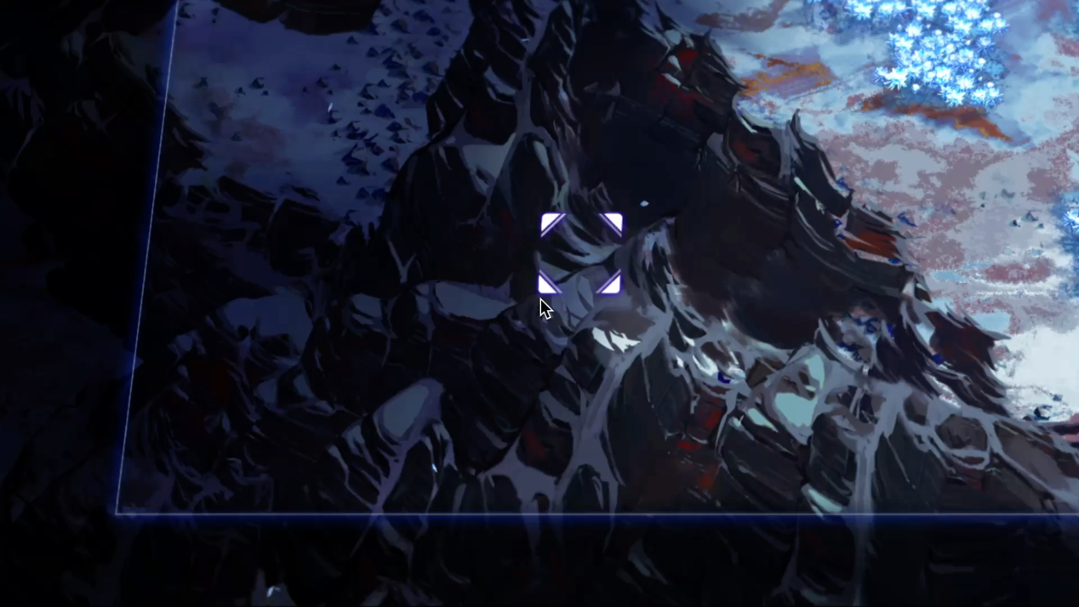to determine material and function formula;

* Spread amount on

After the verification, formulate the schedule, art, procedure and planning, and the three parties carry out in an orderly manner;

* Iterative optimization

The function parameter extraction to the panel for planning of flexible configuration;

The following is the video display:

（RightClick And Play）

-- -- -- -- -- -- -- -- -- -- -- -- -- -- -- -- -- --

* Module: Collect System _ Confidential files

Function description: A secret file system similar to the Assassin's Creed message wall, with a sense of design and easy to configure

* Function and dismantling

Requirements are broken down in the following dimensions:

* Functional layers:

1. The surface of wall function; The containment level of confidential documents, file bags and the documents inside;

2. Document browsing function; Including text, pictures, recordings (including subtitles);

3. Not unlock and the new lock red dot logic;

* UI layer:

1.1 interface _ side wall;

2.2 interface _ envelope;

3.3 _ interface document browsing;

4. Unlocked performance, red dot performance at all levels;

5. Interactive performance; Click and hover;

* Configure layer:

1 envelope to table, 1 file information table, N a text file, a recording the subtitle file;

* Make plan
* Collaboration interface

1. The envelope to the table. Responsible for file bag classification and file bag location information;

Table 2. The file information. Is responsible for the specific configuration of the contents of the documents, including the file type, text, images, audio and video resource path, subtitles paths, ICONS, checkpoint ID, etc.

3. Text files (txt format). Copy/scenario planning;

4. The subtitle file (TXT format). Copy/scenario planning;

* Art direction

1. Provide renderings. Clear surface wall style;

2. Provide all kinds of material. Including has unlocked, not unlock, files and envelope, UE interactive material, etc.;

3. Determine the material path and tables.

4. Design entry, exit the animation performance; Configure the animation in the editor, and reserve the trigger interface;

* Design directions

1. System planning. Clearly show the order and table, using the tool configuration file UE hotspots, acceptance of the overall function;

2. Copy/plot plan. A clear envelope containing content and fill out a form, as well as the specific file text content, subtitles, and export to TXT, standard naming and table;

3. Level planning. Clarify the drop position and other information in the level, and make a chart;

* The program direction

1. The resources to read. Depending on the language set by the player, call different txt content;

2. Document reader. Text content: Design pagination display after reading text; Images: similar to Windows picture viewer, can free to drag, zoom; Audio: play the load automatically when the current language subtitles and display;

3. The red dot logic. Multi-level red dot binding show and disappear logic (multi-level nodes, utilizing binary tree logical structure);

4.UI irregular hot spots. Develop custom editing tools for hot spots;

5.UE interaction. Implement hover and tap feedback;

* Demo verification

With boundary conditions (different language text, audio, picture) test, a small amount of material, lightweight code, quick test feasibility;

* Spread amount on

After the verification, formulate the schedule, art, procedure and planning, and the three parties carry out in an orderly manner;

* Iterative optimization

The level drop position, file wall arrangement position, file bag content and file content are independent of each other, which can be configured separately and independently, with strong flexibility.

The following is the video display: (Video From Bilibili, I haven't unlock yet)

[https://www.bilibili.com/video/BV1nt421F7Kt/?spm_id_from=333.337.search-card.all.click&vd_source=5713d84f1ce3676 777b1752a12a96ab4](https://www.bilibili.com/video/BV1nt421F7Kt/?spm_id_from=333.337.search-card.all.click&vd_source=5713d84f1ce3676%20777b1752a12a96ab4), Ha ha, because I can't use the command in development ~)

PS: The audio function, the post-recording has been cut and replaced with pure subtitles

-- -- -- -- -- -- -- -- -- -- -- -- -- -- -- -- -- -- -- -